1.74: a)
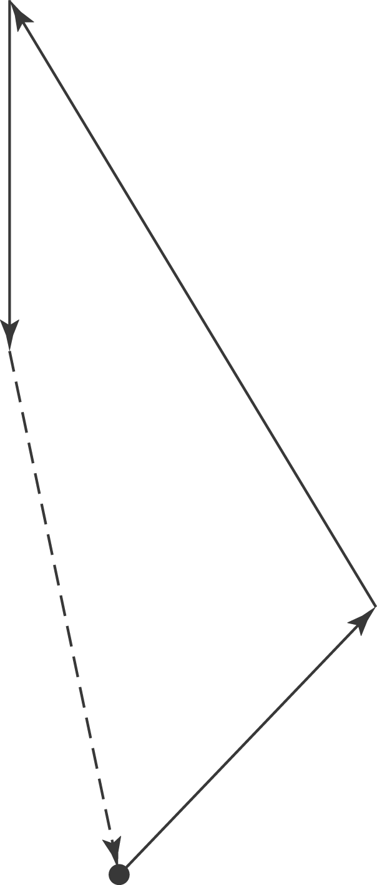

- To use the method of components, let the east direction be the x-direction and the north direction be the y-direction. Then, the explorer’s net x-displacement is, in units of his step size,

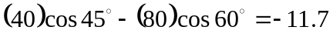

and the y-displacement is

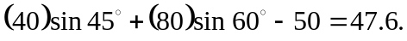

The magnitude and direction of the displacement are

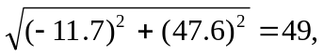 arctan 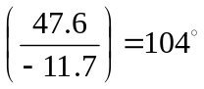.
(More precision in the angle is not warranted, as the given measurements are to the nearest degree.) To return to the hut, the explorer must take 49 steps in a direction 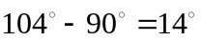 east of south.

